Management Studies: A Gateway to Leadership, Innovation, and Success
Every year, when I meet prospective students and their parents during admission season, I am asked the same honest question: "Why should we choose management studies as a career option" I don't answer that question with a brochure line. I answer it with what we really do in our classrooms and increasingly, that answer has AI, Innovation, Entrepreneurship, and Intellectual Property Rights through it.
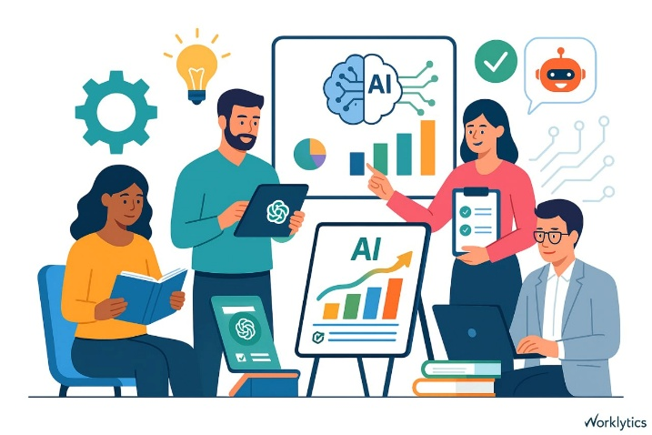
Management Education is not what it used to be:
A decade ago, a management degree meant memorizing theories of Porter and Kotler and reciting them in exams. That world is gone. Business schools worldwide are moving AI from an elective add-on to a foundational competency that every graduate is expected to carry regardless of specialization. At Aggarwal College, we have taken this shift seriously not as a marketing buzzword but as a redesign of how our students learn to think. Our management curriculum today treats AI literacy the way we once treated computer literacy which is strictly non-negotiable. Students work with AI tools for market research, financial forecasting and customer analytics, while also learning the ethics and limitations of relying on machine-generated insights. The goal isn't to replace judgment with automation rather it's to sharpen judgment using automation as a starting point.
Digital Innovation runs through every classroom:
Digital transformation is no longer confined to a "digital marketing" elective. From supply chain simulations to HR analytics dashboards, our faculty integrates real digital tools into core papers so that by the time a student graduates, they've built something concrete like a campaign, a dashboard, a data model which are not just studied one in a textbook. We regularly bring in industry practitioners from Delhi-NCR's fast-growing tech and services sector to co-teach modules to ensure our syllabus doesn't lag what employers are actually asking for.
Entrepreneurship and Startup Culture: Learning by Building

Ballabhgarh and the wider Faridabad-Gurugram belt sit at the edge of one of India's most active startup corridors. We treat that geography as an opportunity, not a footnote. Our management department runs an incubation cell under IIC where students don't just write business plans for grades but they pitch to actual mentors, refine ideas through structured feedback and in several cases have taken early-stage ventures beyond the classroom. Startup culture is at its core teaching something no textbook.
Why we teach IPR seriously?
Here is something that surprises many prospective students: we place real emphasis on Intellectual Property Rights. In a knowledge economy, a brand, a design, a piece of software or a business process can be worth more than physical assets but only if it is protected correctly. Our students learn the basics of patents, trademarks, copyrights and trade secrets not as a dry legal module but as a practical toolkit they'll need the moment, they build something original whether that's a startup product or an innovation inside a large organization.
The bigger shift is we're preparing students for across business education globally:

There's a growing recognition that technical skill alone isn't enough. The employers and researchers alike are pointing to critical thinking, ethical reasoning and human judgment as the differentiators in an AI-saturated workplace. We design our courses with that balance in mind which are not only strong on emerging tools but are equally strong on the human skills including negotiation, leadership, communication that no algorithm can replicate.

Bridging Industry and Academia:
Our management department maintains ongoing conversations with recruiters, alumni, and industry practitioners from the Delhi-NCR corridor to keep our syllabus honest. Guest lectures, live projects and industry-mentored capstone assignments are not occasional events for us in fact they are built into the semester calendar. When a marketing student builds a real campaign brief for a local business or a finance student audits an actual small enterprise's books under faculty supervision, the classroom stops being theoretical. Students see quite concretely where their coursework meets a real balance sheet or a real customer.
Building human skills alongside technical ones:
I want to be candid about something: the more our curriculum leans into AI and digital tools, the more deliberately we've had to protect the human side of management education. We do not want to produce students who can prompt a chatbot well but freeze in a real boardroom conversation. So, alongside our technology-forward modules, we continue to invest heavily in case-based discussions, group projects that require genuine collaboration, presentation skills and leadership simulations. Debate, negotiation exercises, and cross-functional team projects remain central to how we teach,
A learning environment built for today's student:

Practically speaking, what does a semester look like for our management students? It's a mix of classroom instruction, hands-on lab and simulation work, industry interaction and increasingly a self-directed exploration using digital tools. We've moved away from a model where a professor's lecture is the only source of learning in a course. Instead, students are expected to research, validate and present using AI tools to accelerate the groundwork, while faculty focus classroom time on discussion, critique and depth.
We also recognize that today's students are not choosing a college in isolation from their career anxieties. Placement support, internship pipelines, and career counselling are woven into the department's responsibilities not outsourced to a separate cell that only becomes relevant in the final semester. From the first year, students are encouraged to build a portfolio including projects, certifications, a startup pitch, or a research paper so that by graduation, their resume reflects work they've actually done not just courses they've attended.

Dr. Shilpa Goel
Dean n HoD, Department of Management

